DESIGN AND ANALYSIS OF ALGORITHM
NAME: NIVASINI VM
REG NO : 192511356
CO 5-ASSESMENT TOOL 1
Question
Q26. Dominating Set Problem (NP-Complete Problem)
Find a minimum set of vertices such that every vertex is either in the set or adjacent to it.
Clearly define constraints related to domination. Analyze how constraints restrict feasible
solutions. Develop a backtracking-based solution. Apply pruning to reduce search space.
Justify correctness and discuss NP-Complete complexity.
Answer
1. Problem Definition
The Dominating Set Problem is a graph problem in which we need to find the smallest possible set of vertices such that every vertex in the graph is either present in the selected set or directly adjacent to at least one selected vertex. The selected vertices form a dominating set. The objective is to minimize the number of selected vertices.
2. Constraints
Let the graph be represented as G = (V, E), where V is the set of vertices and E is the set of edges. Every vertex must be dominated. A selected vertex dominates itself and all its adjacent vertices. No vertex can be selected more than once. The number of selected vertices should be minimum. A solution is feasible only when all vertices are dominated.
3. Backtracking Approach
Backtracking considers every vertex and makes two choices: include the vertex in the dominating set or exclude it. After each choice, the algorithm checks whether all vertices can still be dominated. Pruning is used when a complete dominating set has already been found with fewer vertices, or when the remaining vertices cannot possibly dominate all uncovered vertices.
4. Python Program
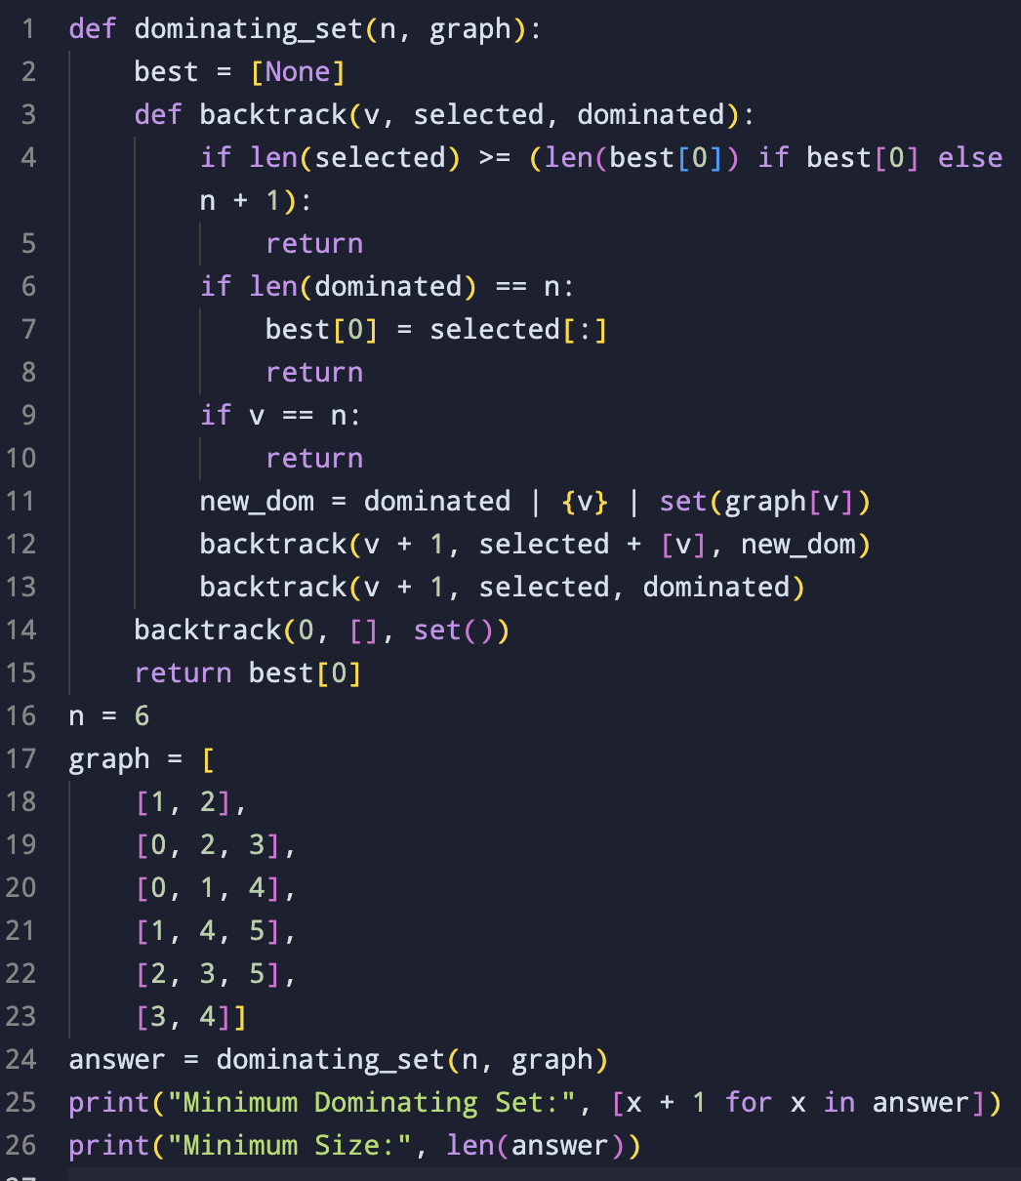5. Input
Number of vertices = 6
Edges:
(1,2)
(1,3)
(2,3)
(2,4)
(3,5)
(4,5)
(4,6)
(5,6)
6. Output
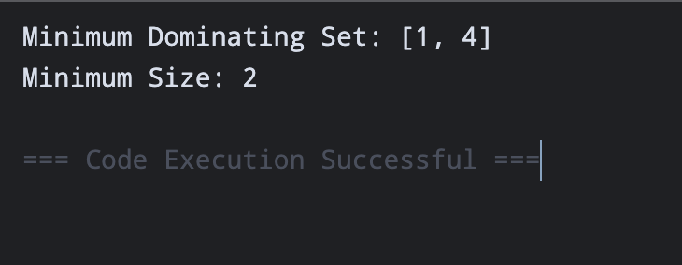7. Verification of the Result
The minimum dominating set obtained is D = {1, 4}. Vertex 1 dominates the vertices {1, 2, 3}, while vertex 4 dominates {2, 4, 5, 6}. Together they cover all six vertices. Therefore, every vertex is dominated. Since the algorithm checks possible selections and retains the smallest valid set, {1, 4} is a minimum dominating set.
8. Pruning
The first pruning condition stops a branch when the current selected set is already equal to or larger than the best solution found. The second pruning condition stops a branch when the uncovered vertices cannot be dominated even by selecting all remaining vertices. These conditions reduce the number of unnecessary recursive calls.
9. Correctness
The algorithm considers both possibilities for every vertex: selecting it or not selecting it. Hence, every possible dominating set can be represented by some branch of the search tree. Whenever all vertices are dominated, the current set is compared with the best solution. The smallest valid set is retained, so the final result is a minimum dominating set.
10. Complexity
For a graph with n vertices, there can be up to 2^n possible subsets of vertices. Therefore, the worst-case time complexity is O(2^n). The recursion and graph representation require approximately O(n) additional space. The Dominating Set Problem is NP-Complete. For a given set of vertices, checking whether it is a dominating set of size at most k can be done in polynomial time, but finding the minimum dominating set is computationally difficult in the general case.
11. Conclusion
The Dominating Set Problem finds the minimum number of vertices required to dominate every vertex in a graph. A backtracking method systematically explores possible solutions, while pruning removes branches that cannot produce a better answer. For the given graph, the minimum dominating set is {1, 4}, with a size of 2. The exponential complexity makes the method difficult to scale for large graphs.

